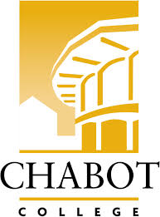
Career Education (CE Committee)
Chabot College – Zoom
Monday, February 10, 2025
12:00-1:00

AGENDA

- Welcome & Land acknowledgement – Robin
- Announcements
  - Professional Development – Out of State Travel
  - Career Widget – ATB Pilot
  - Navigating AI Together: A Community College Unconference – 3/7
  - Career Open House – Foundation Request
- Handshake Presentation- John
- CE Events
  - ROP Careers in Healthcare Day – 3/7
  - CE Open House – 3/22
  - SOAR Day – 4/19
  - ECD Job Fair – 4/29
  - ROP Digital Media Day – 5/2
  - Ambulance Meet & Greet Day – 5/23
- CE Website/Newsletter
- Future Topics
- Good of the Order - Kristina
- Next Meeting 2/24/2025
- Adjournment

Mission Statement
Chabot College is a dynamic, student-centered community college that serves the educational, career, job skill, and personal development needs of our community. We provide culturally responsive, revitalizing, and sustaining learning and support services driven by a goal of equity. Building upon students’ strengths and voices, we empower students to achieve their goals and lead us towards an equitable and sustainable world.

